**Section 2 Mathematics**

2.1 Algebra

Laws

Identities

Equations

Interest & Annuities

2.2 Geometry

2.3 Trigonometry

Graphs

Identities

Oblique Triangle Laws

2.4 Matrix Algebra

2.5 Vector Algebra

2.6 Statistics

2.7 Standard Series

2.8 Derivative Table

2.9 Integral Table

2.10 Laplace Transform Table

2.11 References

**Section 2.1 Algebra**

(reference 2.1)

**LAWS**

commutative: *a+b = b+a*

*ab = ba*

associative: *a+(b+c) = (a+b)+c*

distributive: *a(b+c) = ab+ac*

**IDENTITIES**

exponents: *axay = ax+y*

*(ab) x = axbx*

*(ax)y = axy*

*amn = (am)n*

if

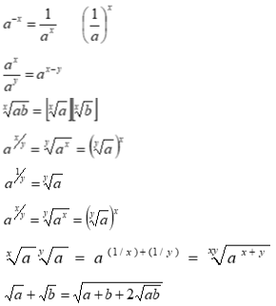

=



logarithms: if M, N,b are positive and

logbb = 1

logb1 = 0

log b MN = log bM + log b N

log b [M/N] = log b M – log b N

log b Mp = p log b M

logb [1/M] = -log b M



logbM = logcM logbc =



examples:

examples: log 6.54 = .8156,

log 6540 = log (6.54 x 103) = .8156 +3 = 3.8156

log .654 = log (6.54 x 10-1) = .8156 -1 = 9.8156 -10

log .000654 = log (6.54 x 10-4) = .8156 -4 = 6.8156 -10

calculate 68.31 x .2754: log 68.31 = 1.8354

log .2754 = -.56

1.8354 +(-.56) = 1.2745

log-1 1.2745 = 18.81

calculate [.6831]1.53: log .6831 = -.1655

1.53 x (-.1655) = -.253

` log-1[-.253] = .5582

calculate [.6831]1/5: log .6831 = -.1655

1/5 x(-.1655) = -.0331

log-1 (-.0331) = .9266

solve for *x* in .6931*x* = 27.54: log[.6931*x*] = log 27.54

*x* log [.6931] = log 27.54

*x* = log 27.54 /log [.6931]

=1.44/[-.1655] = -8.701

**EQUATIONS**

**Quadratic** Equation: for a*x*2 + b*x* + c =0

(has two roots, both real or both complex)



**Cubic** Equation: for y3 + py2 + qy + r = 0

(has three roots, all real or one real & two complex)

let y = x –(p/3) to rewrite equation in form of *x*3 + a*x* + b = 0

where a = (3q –p2)/3 and b = (2p3 – 9pq – 27r)/27

let



and



then x1 = A +B

x2 = -(A + B)/2 + {[-3]1/2/2}(A – B)

x3 = -(A + B)/2 - {[-3]1/2/2}(A – B)

special cases…

if (b2/4 + a3/27 <0), then the real roots are

*x*1,2,3 = 2[-a/3]1/2cos(f/3 + 120ok)

where k = 0,1,2

and cosf = +[(b2/4)/(-a3/27)]1/ 2 if b<0

or cosf = -[(b2/4)/(-a3/27)]1/ 2 if b>0

if (b2/4 + a3/27 >0) and a>0, the single real root is

x = 2[*a*/3]1/2 cot(2f)

where tan(f) = [tan(y)]1/3

and cot(2y) = +[(b2/4)/(-a3/27)]1/ 2 if b<0

or cot(2y) = -[(b2/4)/(-a3/27)]1/ 2 if b>0

if (b2/4 + a3/27 =0), the three real roots are

x1 = -2[-a/3]1/2, x2 =x3 = +[-a/3] /2 1ifb>0

or x1 = +2[-a/3]1/2, x2 =x3 = -[-a/3]1/2 ifb<0

Quartic (biquadratic) Equation: for y4 + py3 + qy2 + ry + s = 0

let [y = x-(p/4)] to rewrite equation as x4 + ax2 + bx + c =0

let *l, m, n* denote roots of the following resolvent cubic…

t3 + at2/2 + (a2 –4c)t/16 – b2/64 = 0

the roots of the quartic are

x1 = +[l]1/2 + [*m*]1/2 + [*n*]1/2

x2 = +[l]1/2 - [*m*]1/2 - [*n*]1/2

x3 = -[l]1/2 + [*m*]1/2 - [*n*]1/2

x4 = -[l]1/2 - [*m*]1/2 + [*n*]1/2

**INTEREST AND ANNUITIES**

(reference 2.3)

Amount:

*P* principal at *i* interest for *n* time accumulates to amount *An*:

simple interest: *An* *= P(1 + ni)*

at interest compounded each *n* interval: *An* = *P(1 + i)n*

at interest compounded *q* times per *n* interval: *An* = *P(1 + r/q)nq*

where *r* is the nominal (quoted) rate of interest

Effective Interest:

The rate per time period at which interest is earned during each pe riod is called the effective rate *i*.

*i = (1 + r/q)q -1*

Solve above equations for *P* to determine investment required now to accumulate to amount *An*

True discount , *D* = *An* – *P*

Annuities:

rent *R* is consistent payment at each period *n*

let



and let



then *An* =*Rsn*

or



present value of an annuity, *A* is the sum of the present values of all the future payments. *A = Rrn*

Monthly interet rate = MIR = (annual interest rate) /12

Month Term = # months in loan

Monthly payment = [amount financed]* [MIR/(1-{1+MIR}-#months)]

Final value (*FV*) of an investment is a function of the initial principal invested (P), interest rate (*r –*expressed as .05 for *5%, .*1 for 10% etc.), time invested (*Y*- typically years), and compounding periods per year (*n* – typically =1 for yearly or =12 for monthly).

*FV*   =   *P* (1  +  *r* / *n*)*Yn*

**Section 2.2 Geometry**

(references 2.1, 2.2)

General definitions:

A = area

a = side length

b = base length

C = circumference

D = diameter

h = height

n = number of sides

R = radius

V = volume

x, y, z = distances along orthogonal coordinate system

b = interior vertex angle

triangle: A = bh/2

sum of interior angles = 180o

rectangle: A = bh

sum of interior angles = 360o

parallelogram (opposite sides parallel):

A = ah = absin b

trapezoid (4 sides, 2 parallel):

A = h(a+b)/2

pentagon, hexagon, and other *n*-sided polygons:

A = {(na2)cot (180o/n)}/4

R = radius of circumscribed circle = {a csc(180o/n)}/2

r = radius of inscribed circle = {a cot(180o/n)}/2

b = 180o –(360o/n)

sum of interior angles = *n*180o-360o

circle: A = pR2

C = 2pR = pD

perimeter of *n*-sided polygon inscribed within a circle

= 2*n*Rsin(p/*n*)

area of circumscribed polygon = *n*R2tan(p/*n*)

area of inscribed polygon = {*n*R2sin(2p/*n*)}/2

equation for a circle with center at (h,k): R2 = (x-h)2 + (y-k)2

ellipse: f = semimajor axis

g = semiminor axis

e = eccentricity = ([f2-g2]1/2)/f

A = pef

equation for ellipse with center at (h,k):

(x-h)2/f2 + (y-k)2/g2 = 1 if major axis along x-axis

or (y-k)2/f2 + (x-h)2/g2 = 1 if major axis along y-axis

distance from center to either focus = [f2-g2]1/2

latus rectum = (2g2)/a

parabola: p = distance from vertex to focus

e = eccentricity = 1

equation for parabola with vertex at (h,k), focus at (h+p,k):

(y-k)2 = 4j(x-h) if (j>0)

equation for parabola with vertex at (h,k), focus at (h,k+p):

(x-h)2 = 4j(y-k) if (j<0)

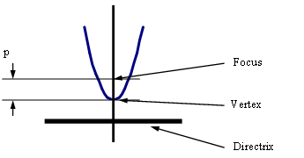

hyperbola: p = distance between center and vertex

q = distance between center and conjugate axis

e = eccentricity = ([p2+q2]1/2)/p

equation for hyperbola centered at (h, k):

(x-h)2/p2 – (y-k)2/q2 = 1 if (asymptotes slopes = +/- q/p)

or (y-k)2/p2 – (x-h)2/q2 = 1 if (asymptotes slopes = +/- p/q)

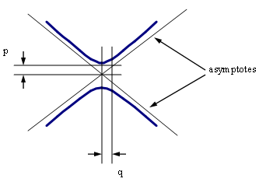

sphere: A = 4pR2

V = 4pR3/3

equation for sphere centered at origin: x2+y2+z2 = R2

torus: A= 4p2Rr

V = 2p2Rr2

r = smaller radius

**Section 2.3 Trigonometery**

(references 2.1, 2.2)

For any right triangle with hypotenuse *h*, an acute angle a, side length *o* opposite from a, and side length *a* adjacent to a, the following terms are defined:

sine a = sin a = *o/h*

cosine a = cos a = *a/h*

tangent a = tan a = *o/a* = sin a /cos a

cotangent a = cot a = ctn a = *a/o =* 1/tan a = cos a /sin a

secant a = sec a = *h/a =* 1/cosa

cosecant a = csc a = *h/o =* 1/sin a

exsecant a = exsec a = sec a -1

versine a = vers a = 1-cos a

coversine a = covers a = 1-sin a

haversine a = hav a = (vers a )/2

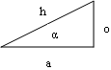

also defined are the following…

hyperbolic sine of *x* = sinh *x* = (*ex – e-x*)/2

hyperbolic cosine of *x* = cosh *x* = (*ex + e-x*)/2

hyperbolic tangent of *x* = tanh *x* = sinh *x*/cosh *x*

csch *x* = 1/sinh *x*

sech *x* = 1/cosh *x*

coth *x* = 1/tanh *x*

**IDENTITIES**

Pythagorean Identities:

sin2 a + cos2 a = 1

1 + tan2 a = sec2 a

1+ cot2 a = csc2 a

Half Angle Identities:

sin [a/2] = +/- [(1 - cos a)/2]1/2

(negative if [a/2] is in quadrant III or IV)

cos [a/2] = +/- [(1 + cos a)/2]1/2

(negative if [a/2] is in quadrant II or III)

tan [a/2] = +/- [(1 - cos a)/(1+cos a)]1/2

(negative if [a/2] is in quadrant II or IV)

Double-Angle Identities

sin 2a = 2sin a cos a

cos 2a = 2cos2 a –1 = 1-2sin2 a = cos2 a - sin2 a

tan 2a = 2tan a /[1-tan2 a]

n –Angle Identities:

sin 3a == 3sin a – 4sin3 a

cos 3a = 4cos3 a – 3cos a

sin na = 2sin (n-1)a cos a – sin (n-2)a

cos na = 2cos (n-1)a cos a – cos (n-2)a

Two-Angle Identities:

sin (a+b) = sin a cos b + cos a sin b

cos (a+b) = cos a cos b – sin a sin b

tan (a+b) = [tan a + tan b]/[1- tan a tan b]

sin (a-b) = sin a cos b - cos a sin b

cos (a-b) = cos a cos b + sin a sin b

tan (a-b) = [tan a - tan b]/[1+ tan a tan b]

Sum and Difference Identities:

sin a + sin b = 2sin [(a+b)/2] cos [(a-b)/2]

sin a – sin b = 2cos{(a+ b)/2] sin {(a- b)/2]

cos a+ cos b = 2cos [(a+b)/2] sin [(a-b)/2]

cos a -cos b = -2cos [(a+b)/2] sin [(a-b)/2]

tan a + tan b = [sin (a + b)]/[cos a cos b]

cot a + cot b = [sin (a + b)]/[sin a sin b]

tan a - tan b = [sin (a - b)]/[cos a cos b]

cot a - cot b = -[sin (a - b)]/[sin a sin b]

sin2 a – sin2 b = sin (a+b) sin (a-b)

cos2 a – cos2 b = -sin (a+b) sin (a-b)

cos2 a – sin2 b = cos (a+b) cos (a-b)

Power Identities:

sin a sin b = [cos (a-b) - cos (a+b)]/2

cos a cos b = [cos (a-b) + cos (a+b)]/2

sin a cos b = [sin (a+b) + sin (a-b)]/2

cos a sin b = [sin (a+b) - sin (a-b)]/2

tan a cot a = sin a csc a = cos a sec a = 1

sin2 a = [1-cos2a]/2

cos2 a= [1+cos2a]/2

sin3 a = [3 sin a– sin 3a]/4

cos3 a = [3 cos a + cos 3a]/4

sin4 a = [3 - 4cos 2a + cos 4a]/8

cos4 a = [3 + 4cos 2a + cos 4a]/8

sin5 a = [10sin a –5sin 3a +sin5a]/16

cos5 a = [10cos a + 5cos 3a + cos5a]/16

OBLIQUE TRIANGLES

(no right angle, angles A,B,C are opposite of legs a,b,c)

Law of Sines: a/sin A = b/sinB = c/sinC

Law of Cosines:

a2 = b2 + c2 – 2bc cos A

b2 = a2 + c2 – 2ac cos B

c2 = a2 + b2 – 2ab cos C

C = cos-1[(a2+b2-c2)/2ab]

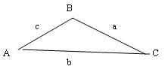

Law of Tangents:

[a-b]/[a+b] = [tan ({a-b}/2]/ [tan ({a+b}/2]

Projection Formulas:

a = b cos C + c cosB

b =c cos A + a cos C

c = a cos B + b cos A

Mollweide’s Check Formulas:

[a-b]/c = [sin ({A-B}/2)]/ cos (C/2)

[a+b]/c = [cos ({A-B}/2)]/ sin (C/2)

**Section 2.4 Matrix Algebra**

(reference 2.5)

Matrix **multiplication** can be defined for any two matrices only whe the number of columns of the first is equal to the number of rows of the second matrix. Multiplication is not defined for other matrices.

[*A*][*B*] = [*C*]

[*aim*][*bmj*] = [*cij*]

The product of a pair of, 2´ 2 matrices is:



The **identity** (or unit) matrix [*I*] occupies the same position in matrix algebra that the value of unity does in ordinary algebra. That is, for any matrix

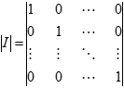

[*A*]: [*I*][*A*] = [*A*][*I*] = [*A*]

The identity [*I*] is a square matrix consisting of ones on the principle diagonal and zeros everywhere else; i.e.:

*a* × *a*-1 = *a*1-1 = *a*0 = 1

In the same way, the matrix [*A*]-1 is called the inverse matrix of [*A*] since:

[*A*][*A*]-1 = [*A*]-1[*A*] = [*A*]0 = [*I*]

# Cofactors and Determinates

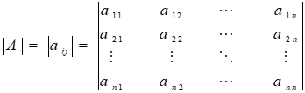

The signed minor, with the sign determined by the sum of the row and column, is called the **cofactor** of *aij* and is denoted by:

*Aij* = (-1)*i+j Mij*

The value of the **determinant** is equal to the sum of the products of the

elements of any single row or column and their respective cofactors.

Arbitrarily expanding about the first row of a 3 x 3 matrix gives the

determinant:

|*A*| = *a11A11  + a12A12 + a13A13  =*



which expands to give the final solution:

|*A*| = *a*11(*a*22 *a*33 - *a*23 *a*32) - *a*12(*a*21 *a*33 - *a*23 *a*31) + *a*13(*a*21 *a*32 - *a*22 *a*31)

There is a straightforward four-step method for computing the **inverse** of a

given matrix [*A*]:

**Step 1** Compute the determinant of [*A*]. This determinant is written |*A*|. If the determinant is zero or does not exist, the matrix [*A*] is defined as singular and an inverse cannot be found.

**Step 2** Transpose matrix [*A*]. The resultant matrix is written [*A*]*T*.

**Step 3** Replace each element aij of the transposed matrix by its cofactor *Aij*. This resulting matrix is defined as the adjoint of matrix [*A*] and is written Adj[*A*].

**Step 4** Divide the adjoint matrix by the scalar value of the determinant of [*A*] which was computed in Step 1. The resulting matrix is the inverse and is written [*A*]-1.

*Example:* Given the following set of simultaneous equations, solve for

*x*1, *x*2, and *x*3.

3*x*1  *+*  2*x*2  *-*  2*x*3 = *y*1

*- x*1  *+ x*2  + 4*x*3 = *y*2

2*x*1  *-*  3*x*2 + 4*x*3 = *y*3

This set of equations can be written as: [*A*] [*x*] = [*y*]

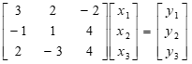

and solved as follows: [*x*] = [*A*]-1 [*y*]

Thus, the system can be solved for the values of *x*1, *x*2, and *x*3 by computing the inverse of [*A*].

**Step 1.** Compute the determinant of [*A*]. Expanding about the first row

|*A*|  *=* 3(4 + 12) - 2 (-4 -8) -2 (3 - 2)

|*A*|  *=* 48 + 24 -2 = 70

**Step 2.** Transpose [*A*].

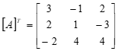

**Step 3.** Determine the adjoint matrix by replacing each element in [*A*]*T* by its Cofactor.

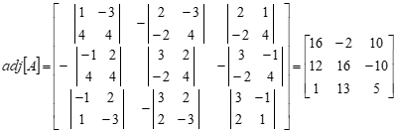

**Step 4.** Divide by the scalar value of the determinant of[*A*]which was computed as 70 in Step 1.



if *y*1 = 1, *y*2 = 13, and *y*3 = 8

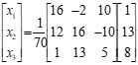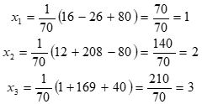

**Cramer’s Rule**

Given matrices A{x} = {b}

If the det (D) of a matrix (A) exists, and Dr is the det of the matrix obtained from A by replacing the rth column of A by the column {b}, then the solution to (1) is xr = Dr/D r = 1,2,…,n

Example of Cramer’s Rule

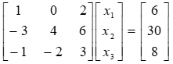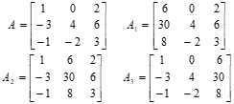

**Section 2.5 VectorAlgebra**

(reference 2.5)

Addition

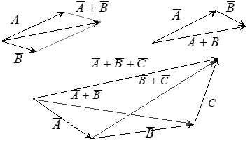

.

Subtraction

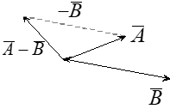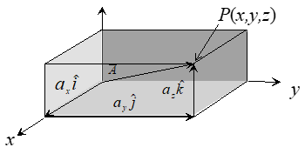

**Dot Product**

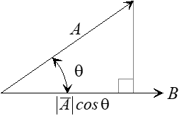

**Vector Product**

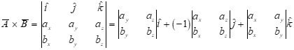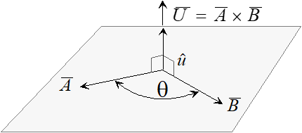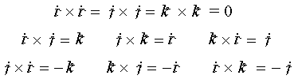

**Vector Differentiation**

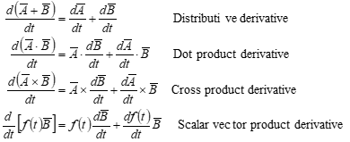

The first derivative of a position vector is a vector tangential to the trajectory with a magnitude equal to the speed of the particle.

**Motion of a point using two reference systems**.

Reference A can be considered the inertial frame while Rotation of the B reference relative to the A reference must be considered when observing motion wrt the A reference system.

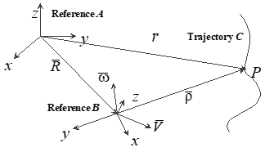

Note: Unit vectors are along the B system axes. Subscripts denote reference system. Reference B can be equivalent to a maneuvering aircraft.

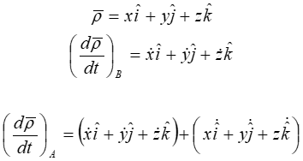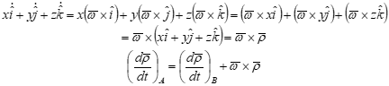

The velocities of the particle *P* relative to the *A* and to the *B* references are, respectively:



These velocities can be related by noting that:



Differentiating with respect to time for the *A* reference,

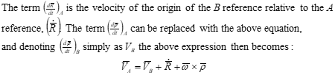

The term is the “transport velocity” and is the only velocity if



point P is rigidly attached to reference B.

where is the centripetal acceleration,

is the Coriolis acceleration, and

is the transport acceleration and is the only acceleration if point P is rigidly attached to reference B.

To get acceleration wrt *A*, differentiate:

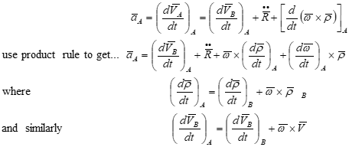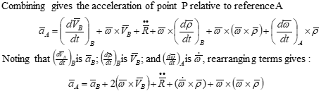

where



is the centripetal acceleration,



is the Coriolis acceleration, and



is the transport acceleration and is the only acceleration if point P is rigidly attached to reference B.

**Motion of a point using one reference system**.

Reference A can be considered the inertial frame while

The body can be equivalent to a maneuvering aircraft.

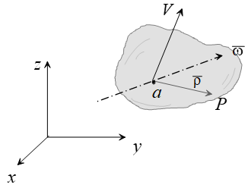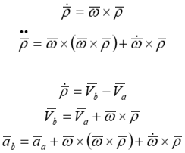

**Section 2.6 Statistics** (reference 2.6)

**Definitions:**

Population: The set of all possible observations

Sample: Any subset of a population

Homogeneous Sample: The sample comes from 1 population only

Random Sample: Equal probability of selecting any member of the population Independence (of events A and B): P(A and B) = P(A)*P(B)

Sample and Population Mean (Average value):



Mode (Most commonly occurring value in a sample)

Median (middle value, 50th percentile. Half of the sample values are greater and half are smaller)

Deviation (from the mean value):



Population Variance (from the mean value):



Population Standard Deviation (from the mean value):



Sample Standard Deviation (from the mean value):



**Discrete Probability Distributions:**

**Binomial:** N independent events, each having probability *p* of success, and1-*p* of failure. For example, tossing a fair coin N times where *p =* the probability of getting a head on any toss. If the random variable x indicates the number of heads in N=2 tosses, then P(x=0) = 1/4, P(x=1) = 1/2, P(x=2) = 1/4. If N=4, then the probabilities are illus trated in the following graph:

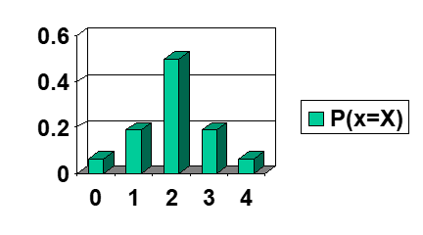

As N approaches infinity ...

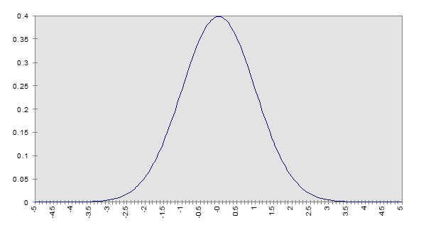

So**,** the binomial distribution is the discrete case of the Normal distribution.

**Continuous Distributions:** As the number of samples increases and the width of the Discrete sample intervals shrink to zero, discrete distributions become continuous.

P(x=X) = 0

Must talk about intervals, e.g. P(a < x < b)

**The Normal Distribution:**

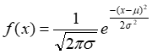

**Normal Distribution:**

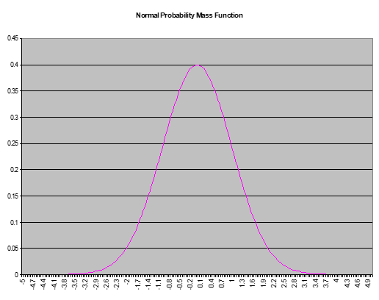



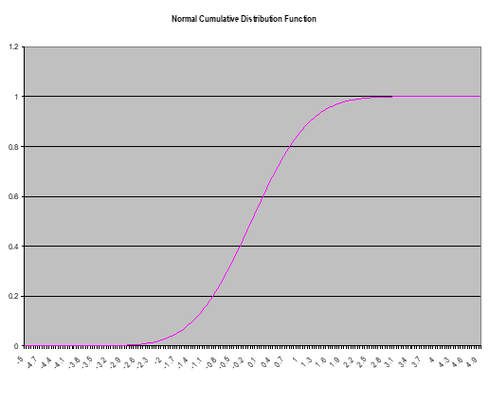

**The Standard Normal Distribution:**

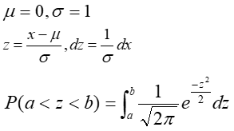

**Error Probable:** An error budget that would contain half of the population data points. Assumes that events are independent and identically distributed (iid). **Also assumes N is large (greater than 30), or population is normally distributed.**

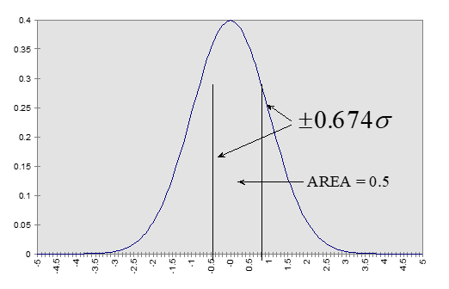

**Circular Error Probable – the 2 Dimensional Case (X error and Y error):**

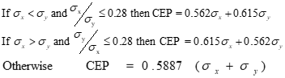

**Confidence Intervals:** In practice, we take a sample from population. The sample mean and variance will differ from the population mean and variance. Confidence Intervals express how certain we are that the population statistics lie in a region around the sample statistics.

**Central Limit Theorem:** Given a population Normally distributed,



then the distribution of successive sample means from samples of n observations

Approaches a Normal distribution with parameters



We want 1- level of confidence that a region around our sample mean



value contains the actual population mean.



**If n < 30, we must use Student’s T Distribution instead of the Standard Normal**



**Determining Sample Size:** For the population mean to fall into an interval defined by



Where is the accuracy desired (or the error that can be tolerated).

Since the sample size decision must be made prior to the test, an estimate must be made for the population standard deviation. Using the estimate we can solve for N



**Hypothesis Testing:** Begins with an assumption (hypothesis), usually about the underlying population distribution of some measured quantity or computed error. Select values for the hypothesis and alternate hypothesis(es) that partition the sample space. Collect N samples of the population test statistic or parameter. There are two types of errors: Type 1 errors reject the hypothesis when it is true; Type II accept the hypothesis when in is false.

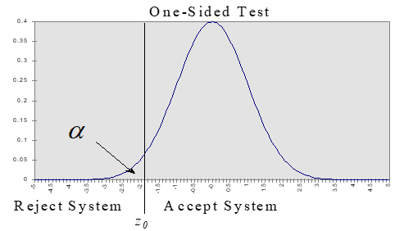

Large Samples, Unknown Variance use: for



Small Samples, Unknown Variance use:



**Adjusting and**



Adjust the size of the Error we wish to Detect Change the sample size *n*



**2.7 Standard Series**

(reference 2.4)

Taylor’s



Maclaurin’s (Taylor series with *a* = 0 ):



Binomial:



Exponential:



Logarithmic:



Trigonometric:



**Section 2.8 Derivative Table**

(references 2.2, 2.3)

[*x* is the independent variable; *u* and *v* are dependent on *x; w* is dependent on *u; a* and *n* are constants; *log* is common logarithm; *ln* is logarithm to the base *e*]



**Section 2.9 Integral Table**

(references 2.2, 2.3)

*x* is any variable, *u* is any function of *x*, *a* & *b* are arbitrary constants.

*The constant of integration, c, has been omitted from this table*

*but should be added to the result of every integration*.

Fundamental Integrals



Expressions containing exponential and logarithmic functions



**Expressions containing trigonometric functions**



**Section 2.10 Laplace Table**

(references 2.2, 2.3)

|  |  |
| --- | --- |
| time domain *f(t)* | frequency domain F(s)=*L*{*f(t)*} |
| 1 (step function) | 1/s (s>0) |
| t | 1/s2 (s>0) |
|  | (s>0) |
|  | (s>0) |
|  | (s>0) |
| tn-1/2 (n=1,2,…) | (s>0) |
| eat | (s>a) |
| teat | (s>a) |
| tn-1eax (n=1, 2, …) | (s>a) |
| sin at | (s>0) |
| cos at | (s>0) |
| ebt sin at | (s?b) |
| ebt cos at | (s>b) |
| x sin ax | (s>a) |
| **x cos ax** | (s > 0) |
| sinh at |  |



|  |  |
| --- | --- |
| cosh at |  |
| sin (at + b) |  |
| cos(at + b) |  |
|  |  |
|  |  |
| d (impulse function) | 1 |
| square wave, period =2c |  |
| triangular wave, period = 2c |  |
| *at* for  sawtooth wave, period = c |  |
| sin *at* sin *bt* |  |
|  |  |
|  |  |
|  |  |



**Section 2.11 References**

2.1 Burington, Richard S., “Handbook of Mathematical Tables and Formulas”, McGraw-Hill Inc., 1973.

2.2 Ayers, F., Moyer, R., “Trigonometry”, Schaum’s Outline series, McGraw-Hill Inc., 1990.

2.3 Esbach, Ovid W., “Handbook of Engineering Fundamentals”, John Wiley and Sons Inc., 1963.

2.4 Hudson, Ralph G., “The Engineers’ Manual”, John Wiley and Sons Inc., 1944.

2.5 Jones, G., *Chapter 14, Vectors and Matrices* , from “*Chapter 14, Vectors and Matrices* , from “ Flying Qualities Testing, Vol II” , National; Test Pilot School, P.O. Box 658, Mojave CA, 93501.

2.6 Flying Qualities Testing, Vol II”, 1997, National Test Pilot School, P.O. Box 658, Mojave CA, 93501.

2.7 Lewis, G., *Chapter 2, Data Analysis* , from “Crew station Evaluation and Data Analysis, Vol IV”, 1997, National Test Pilot School, P.O. Box 658, Mojave CA, 93501.